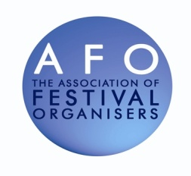
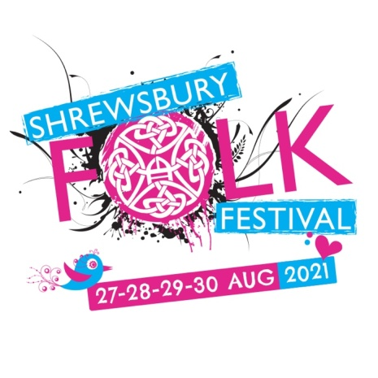
26-27-28-29 August 2022 VAT number 947 8149 75

SOUVENIR PROGRAMME ADVERTISING ORDER FORM
Name…………………………………………………………………….
Company………………………………………………………………..
Address………………………………………………………………….
…………………………………………………………………………...
Post Code……………………………………………………………….
Tel No……………………………………………………………………
Email…………………………………………………………………….

- Programme print run: 4,000 will reach 7,000
- A5 portrait full colour on 120 gsm paper
- Ad format: Adobe Acrobat Press-Ready PDF, high resolution JPEG or TIFF (300 dpi or over)
- Artwork deadline: 30 June 2022

 | Description (2022) advertising rates | Dimensions inmillimetres | Rate | VAT | Total inc VAT
◻ | Full page colour portrait (outside back cover) | 148 wide x 210 high with 4mm bleed on all sides | £410 | £82 | £492
◻ | Full page colour portrait (inside back cover) | 134 wide x 200 high | £335 | £67 | £402
◻ | Full page colour portrait (inside front cover) | 134 wide x 200 high | £335 | £67 | £402
◻ | Full page colour portrait (positioned anywhere) | 134 wide x 200 high | £265 | £53 | £318
◻ | Half page colour portrait (positioned anywhere) | 64 wide x 200 high | £215 | £43 | £258
◻ | Half page colour landscape (positioned anywhere) | 134 wide x 97 high | £215 | £43 | £258
◻ | Quarter page colour portrait (positioned anywhere) | 64 wide x 97 high | £165 | £33 | £198

Once your bookingform has been received, an invoice will be issued.

Your requested spacein the programme will NOT be confirmed until payment is received.

Please sendyour booking form and artworkto alison@shrewsburyfolkfestival.co.uk

Note that artwork received after the deadline will not be used.
A receipt and a copy of the programme will be sent to you after the festival.

